**CHAPTER 1:**

**PLANTATION AND ADOPTION OF TREES**

Tree plantation is the process of transplantation of saplings or sowing of seeds in order to facilitate green cover and promote afforestation.

Adoption of trees is the act of caring, safeguarding and nurturing of said plants and trees for a certain time period.

To learn more about plantation, vegetation and flora, my friends and I visited Lalbagh botanical garden, Bengaluru. Lalbagh houses India’s largest collection of tropical plants and sub-tropical plants, including trees that are several centuries old. We took a pleasant stroll around the beautiful garden and came across a magnificent mango tree.

According to local officials, this mango tree is estimated to be 250 years old. It is said that several mango trees were planted by Hyder Ali and his son Tipu Sultan. But only one such mango tree remains rooted until today.

We decided to contribute to the well-being of the tree by volunteering to its health, safety, protection etc.

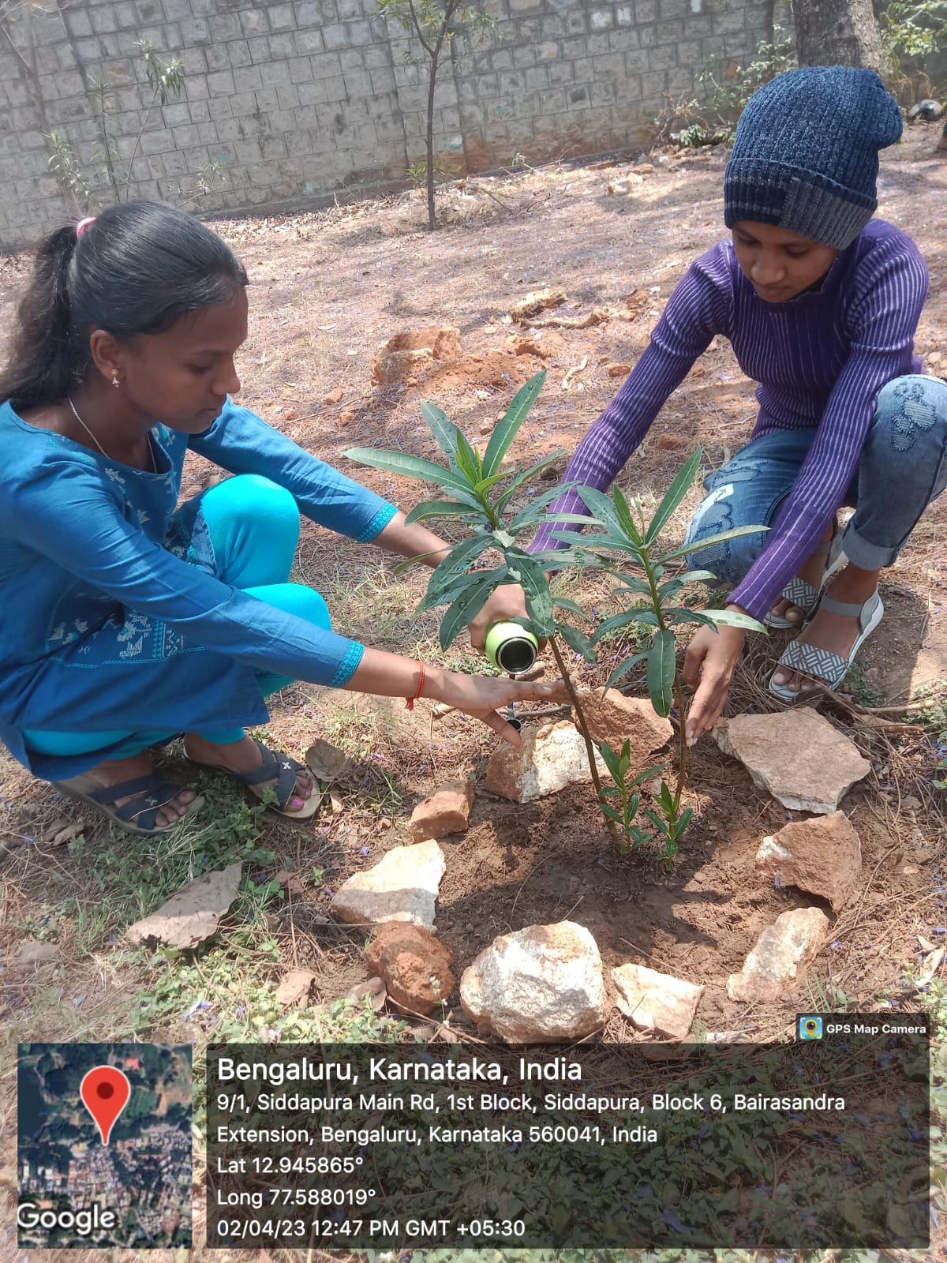

**Here are some basic scientific facts about Mango tree:**

• The mango is an edible stone fruit produced by the tropical tree Mangifera

indica.

• It is believed to have originated between northwestern Myanmar,

Bangladesh, and northeastern India.

• A mango tree can grow quickly and quite large, reaching a height of 100 feet or more with a canopy of 35 feet or more.

•The large leaves of a mango tree are leathery, 5 to 16 inches in length, and remain on the tree for a year or more.

• Flowers are produced in terminal panicles or clusters 4 to 16 inches long. Each flower is small with white petals and a mild sweet aroma. (A mango fruit tree in full flower in the optimal mango tree growing zone is a beautiful sight indeed).

• In terms of mango tree growth stages, it takes approximately four months for the mangos to mature on the tree before they’re ready for harvest. During that time, the fruit-laden branches of the mango tree may bow under the weight of the developing mangos.

• Each fruit is harvested by hand, providing jobs for local workers and a safe passage to the packinghouse for the mangos.

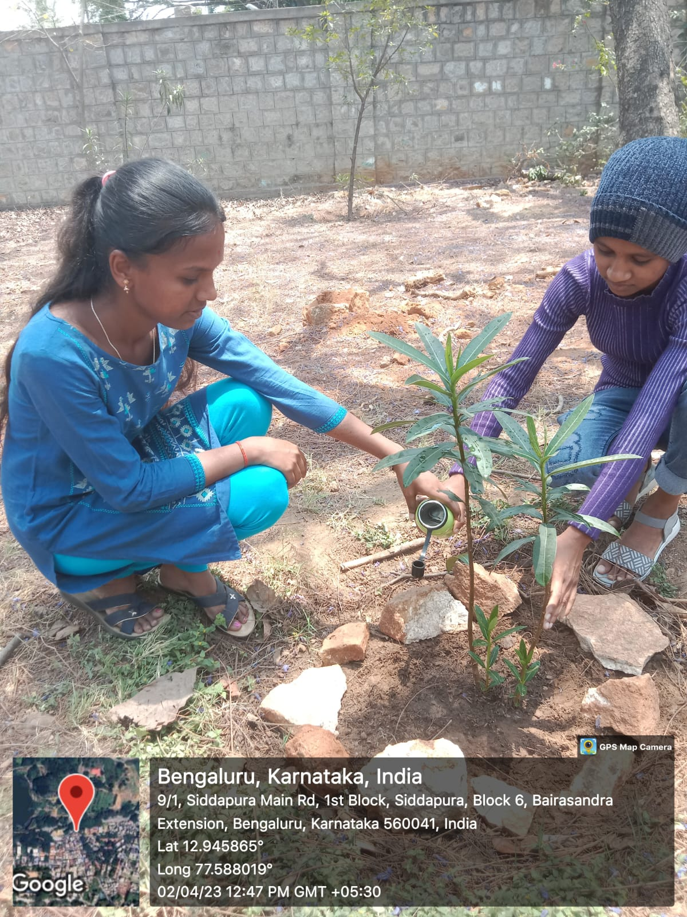

**THE BENEFITS OF PLANTING TREES:**

**There are a lot of benefits of planting trees, including the followin**g:

**THEY SUPPORT THE ECONOMY**

Trees create jobs for thousands of people all over the world.

Farmers spend their days in forests and orchards, reaping the endless benefits of trees. Trees provide food, shelter, and so many of the things we take for granted.

Give back the best way you know how and plant a few trees.

**ABSORB HARMFUL GASES**

It’s no secret that our air quality is not what it used to be. Harmful greenhouse gases have been building up in the atmosphere, creating a dangerous bubble. According to the [Intergovernmental Panel on Climate Change (IPCC)](http://www.bbc.com/news/science-environment-24021772) the majority of greenhouse gas is made up of carbon dioxide (CO2).

The benefits of planting trees to absorb these gases is truly a no-brainer. Trees soak up CO2 naturally, creating cleaner, healthier air for us.

Trees store CO2, decreasing the CO2 concentration in the atmosphere, but what’s more is that they use it. During photosynthesis, CO2 is used to produce sugar, thus providing energy and releasing oxygen.

Trees can also store quite a bit of CO2. The average-sized tree can store hundreds of pounds over the course of its lifetime.

**SUPPORT WILDLIFE**

The first obvious benefit of planting trees is they create homes for wildlife. Dozens of critters, insects, and birds use trees as shelter, food sources, and homes. Planting trees also contribute to growing the diversity of flora and fauna in the area.

Depending on the type of tree that’s planted, additional flowers, leaves, and fruits are used by the wildlife. The detritus of these also enriches the soil once they fall, creating even more places for wildlife to burrow underneath for safety and security. Trees also create a shady sanctuary from extreme temperatures and storms.

**IMPROVE MENTAL HEALTH**

Living close to trees improves our mental health, [recent studies show](https://www.washingtonpost.com/news/energy-environment/wp/2015/07/09/scientists-have-discovered-that-living-near-trees-is-good-for-your-health/?utm_term=.c2f970466af7). Being close to nature positively impacts our cognitive and psychological health, as well as reduces stress and

Looking for more energy in your life? Experience natural energy boosts from [Vitamin B Complex](https://www.nuenergy.org/go-green-inside-learn-vitamin-b-complex-key-natural-energy-body/).

**OFFSETS ENVIRONMENTAL IMPACTS**

Trees act as nature’s buffers. They act as natural flood control, improve neighbourhoods, and decrease adverse effects from man-made environmental changes.

Tree’s natural production of oxygen and reduction of smog and its effect in large cities creates cleaner, healthier spaces for us.

**ACT AS FLOOD CONTROL**

As storms become more and more severe, cities and states are turning towards trees to minimize the damage.

New studies suggest that trees planted around rivers may reduce the height of flooding as much as [20 percent](http://www.bbc.com/news/science-environment-35777927).

**CHAPTER 2:**

**HERITAGE WALK**

**Lalbagh – The Natural Beauty in Bangalore That Draws Attention**.

Lalbagh Botanical Garden or simply Lalbagh is a botanical garden in Bengaluru, India with an over 200 – year history. This garden is of royal origin and was first planned and laid out during the time of Hyder Ali in a region of 40 acres of land and later managed under numerous British Superintendents before Indian Independence. It was responsible for the introduction and propagation of numerous ornamental plants as well as those of economic value. It also served a social function as a park and recreational space, with a central glass house dating from 1890 which was used for flower shows.

A **Bagh** is Hindustani for garden while the reference of the prefix Lal is debated and could refer to red due to its original floral composition, but Lal also means "beloved". Over the years it acquired India's first lawn-clock and the subcontinent's largest collection of rare plants. After the British conquest of Mysore in 1799, this magnificent garden came under supervision of British rule. A horticultural society was formed by William Munro, a botanist in charge of Bangalore chapter then.

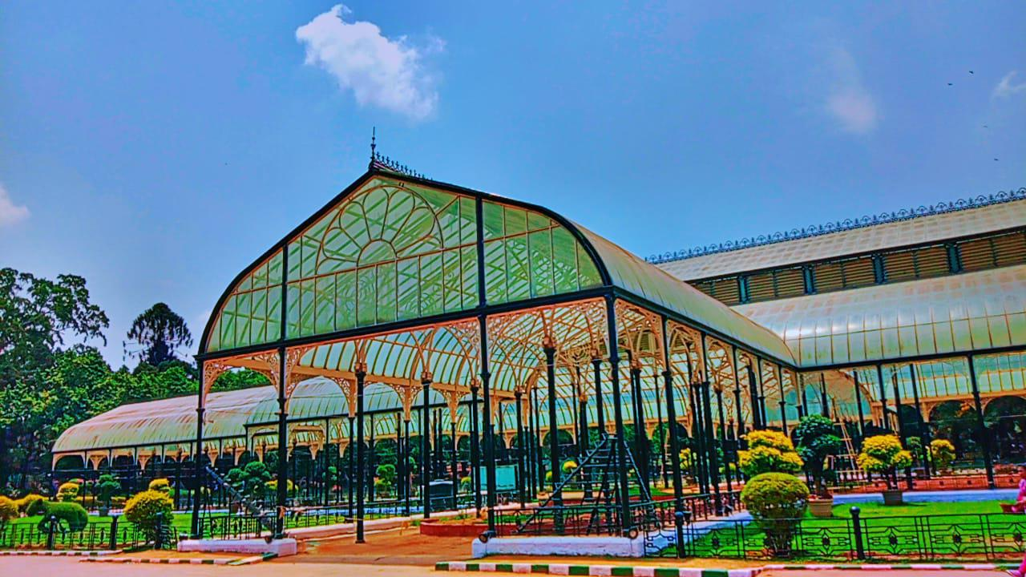

Under the orders of Mysore Commissioner, Sir Mark Cubbon – the Lalbagh gardens was developed to a greater extent. In 1890, a central bandstand and glass house was commission and housed many rare species of plants and flowers whose were from distant lands like Africa, Caribbean, Yemen etc.

In nearly a century, Lalbagh has grown from being 40 acres of land to 240 acres and having over 1000 species of plants with many greater trees that are more than a hundred years old.

The garden adjoins one of the towers erected by the founder of Bangalore, Kempe Gowda. This tower is one among the four towers built to mark the outer most boundaries of Bangalore in the year 1537.

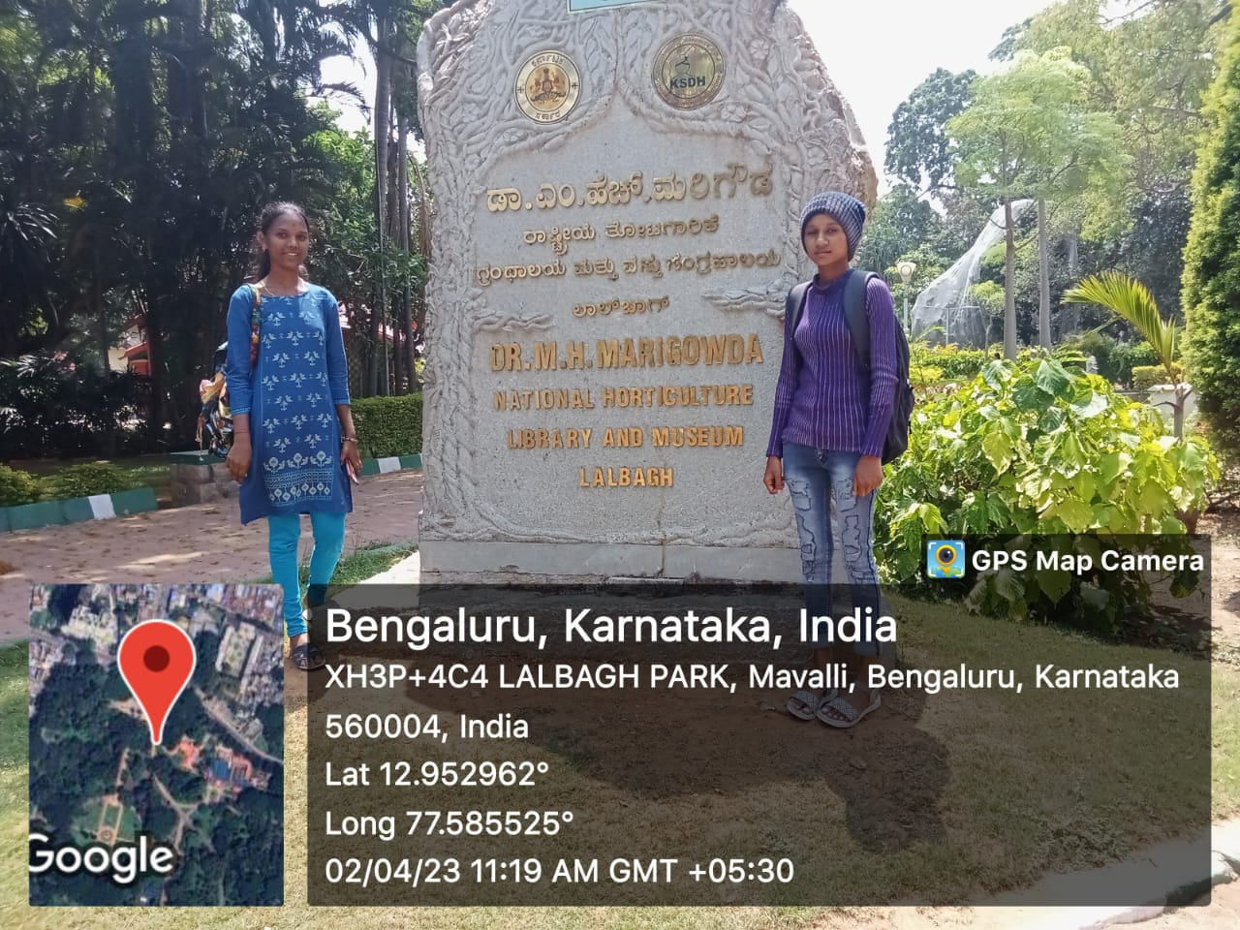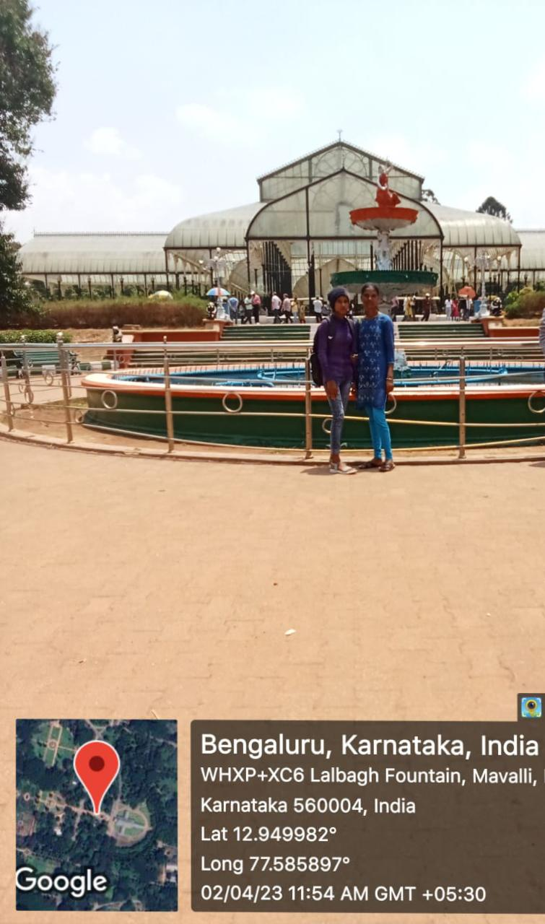

This tower is said to be built on **The Lalbagh Rock**, which is one of the most ancient rock formations on earth dating back to 3000 million years. This rock formation is declared as a geological monument by National Geological survey of India making Lalbagh one of the iconic historic locations and indeed a part of our great heritage.

Lalbagh is a popular botanical garden situated in Bangalore (Bengaluru). This garden is a home to a variety of flora and fauna. There are many different kinds of bird species found here like Myna, Common Egret, Parakeets, and Pond Heron etc.

Lalbagh Botanical Garden also has a glass house, an aquarium and a lake that adds to the already existing beauty of the garden. There are two annual flower shows celebrated in the glass house. The largest collection of tropical plants in India is at Lalbagh.

This garden has also promoted and cultivated the concept of horticulture and is under the protection of Directorate of Horticulture. It is spread over 240 acres. It is one of the major tourist attractions in [Bangalore](https://www.karnataka.com/bangalore/about-bangalore/).

**Quick Facts about Lalbagh, Bengaluru**

* **Timings**: 6:00 am -7:00 pm every day.
* **Entry fee:** INR 20 for visitor’s above12. Free for walkers (Morning: 6:00 AM -9:00 AM, Evening- 6:00 PM -7:00 PM
* **Camera Allowed**: Yes.
* **Camera Charges**: INR 30
* **Approximate visit duration:**2-3 hours
* **Address**: Lalbagh, Bangalore-560004.

**History: the story of Lalbagh**

During the reign of Hyder Ali in 1760, the construction of this garden started but was later on completed on the orders of his son, Tipu Sultan. During that time Mughal gardens were capturing great popularity due to which Hyder Ali wanted to cultivate this exquisite botanical garden.

The garden gained more importance when his son Tipu Sultan added the concept of horticulture in the garden. Many different species of plants were imported from different countries making this garden the apple of everyone’s eye. The garden is built similar to the design used in Mughal gardens.

**Things of interest at Lalbagh, Bangalore**

As mentioned earlier Lalbagh is spread over 240 acres and houses many interesting things. There are many places inside this garden.

**Glass Door:** The glass door that is the major hub for horticulture was developed in 1890 and is modelled like the Crystal Palace of London that accidently caught fire and was ruined in 1936. The annual flower show is carried in the glass house. There is flower clock inside the garden that works on the electronic quartz mechanism. The clock dial is approx. 7 meters in diameter and is beautifully decorated with multi-colored flowers.

**Lake:** There is a Lotus Lake inside the garden apart from huge the Lalbagh Lake.

**Peninsular Gneiss Rock:** The rock is one of the oldest existing rocks in the world. There is a small monument constructed on this rock that has won the recognition of National Geological Monument. This garden is a full package of entertainment and knowledge.

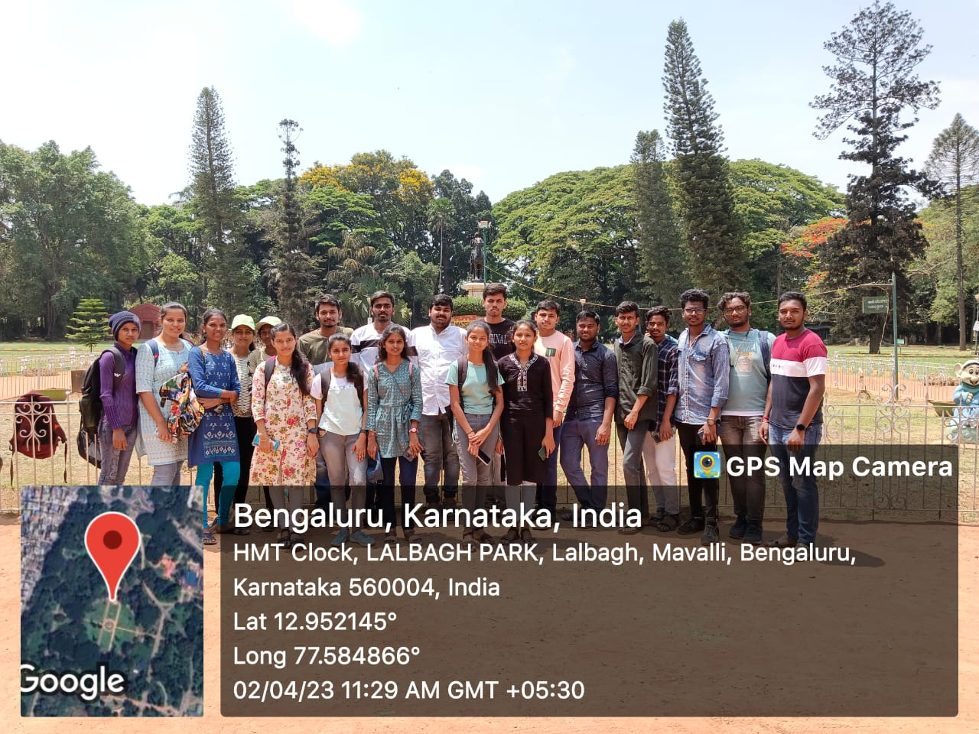

**Interesting facts that not many people know about Lalbagh, Bangalore**

* The flower show started 102 years back by the members of Mysore Horticulture Society.
* It was declared a botanical garden in 1856 during British Empire.
* British rulers did help in maintaining and expanding the garden.
* The garden was first built as a private garden of 40 acres but was later expanded by Tipu Sultan.
* The two annual flower shows were earlier known as the summer and the winter shows.

**CHAPTER 3:**

**ORGANIC FARMING AND WASTE MANAGEMENT**

287

E. Lichtfouse (ed.), Agroecology and Strategies for Climate Change,

Sustainable Agriculture Reviews 8, DOI 10.1007/978-94-007-1905-7_12,

© Springer Science+Business Media B.V. 2012

Abstract Organic farming involves holistic production systems that avoids the use

of synthetic fertilizers, pesticides and genetically modiﬁed organisms, thereby mini-

mizing their deleterious effect on environment. Agriculture area under organic

farming ranges from 0.03% in India to 11.3% in Austria. Organic farming is beneﬁ-

cial for natural resources and the environment. Organic farming is a system that

favors maximum use of organic materials and microbial fertilizers to improve soil

health and to increase yield. Organic farming has a long history but show a recent

and rapid rise. This article explains the development stages, techniques and status of

organic farming worldwide. The sections are: the development and essential charac-

teristics of organic farming; the basic concepts behind organic farming; historical

background; developmental era of organic farming; methods of organic farming;

relevance of organic farming in the Indian context; comparative account between

organic farming and conventional farming; importance of organic farming in envi-

ronmentally friendly approaches; working with natural cycles; relevance of organic

crop production in food security; yield potential and trends of organic farming; rural

economic linkage its scope and limitations; and legislation procedures adopted by

various countries. Organisations and ﬁnancial aspects of organic farming are brieﬂy

discussed.

287

E. Lichtfouse (ed.), Agroecology and Strategies for Climate Change,

Sustainable Agriculture Reviews 8, DOI 10.1007/978-94-007-1905-7_12,

© Springer Science+Business Media B.V. 2012

Abstract Organic farming involves holistic production systems that avoids the use

of synthetic fertilizers, pesticides and genetically modiﬁed organisms, thereby mini-

mizing their deleterious effect on environment. Agriculture area under organic

farming ranges from 0.03% in India to 11.3% in Austria. Organic farming is beneﬁ-

cial for natural resources and the environment. Organic farming is a system that

favors maximum use of organic materials and microbial fertilizers to improve soil

health and to increase yield. Organic farming has a long history but show a recent

and rapid rise. This article explains the development stages, techniques and status of

organic farming worldwide. The sections are: the development and essential charac-

teristics of organic farming; the basic concepts behind organic farming; historical

background; developmental era of organic farming; methods of organic farming;

relevance of organic farming in the Indian context; comparative account between

organic farming and conventional farming; importance of organic farming in envi-

ronmentally friendly approaches; working with natural cycles; relevance of organic

crop production in food security; yield potential and trends of organic farming; rural

economic linkage its scope and limitations; and legislation procedures adopted by

various countries. Organisations and ﬁnancial aspects of organic farming are brieﬂy

discussed.

Keywords /RGANICFARMINGs&ARMINGSYSTEMs"IODIVERSITYs!RBUSCULARMYCORRHIZAL

FUNGIs#ONVENTIONALAGRICULTUREs.UTRIENTMANAGEMENTs(ABITATMANAGEMENT

K.K. Behera (*s!!LAMs36ATSs63HARMA

Department of Bioscience and Biotechnology, Banasthali University,

Banasthali, Rajasthan, 304022, India

e-mail: kambaska@yahoo.co.in

(0D3HARMA

University Departments of Botany, Ranchi University,

Ranchi, India

Organic Farming History and Techniques

Kambaska Kumar Behera, Afroz Alam, Sharad Vats,

Hunuman Pd. Sharma, and Vinay Sharma

287

E. Lichtfouse (ed.), Agroecology and Strategies for Climate Change,

Sustainable Agriculture Reviews 8, DOI 10.1007/978-94-007-1905-7_12,

© Springer Science+Business Media B.V. 2012

Abstract Organic farming involves holistic production systems that avoids the use

of synthetic fertilizers, pesticides and genetically modiﬁed organisms, thereby mini-

mizing their deleterious effect on environment. Agriculture area under organic

farming ranges from 0.03% in India to 11.3% in Austria. Organic farming is beneﬁ-

cial for natural resources and the environment. Organic farming is a system that

favors maximum use of organic materials and microbial fertilizers to improve soil

health and to increase yield. Organic farming has a long history but show a recent

and rapid rise. This article explains the development stages, techniques and status of

organic farming worldwide. The sections are: the development and essential charac-

teristics of organic farming; the basic concepts behind organic farming; historical

background; developmental era of organic farming; methods of organic farming;

relevance of organic farming in the Indian context; comparative account between

organic farming and conventional farming; importance of organic farming in envi-

ronmentally friendly approaches; working with natural cycles; relevance of organic

crop production in food security; yield potential and trends of organic farming; rural

economic linkage its scope and limitations; and legislation procedures adopted by

various countries. Organisations and ﬁnancial aspects of organic farming are brieﬂy

discussed.

Keywords /RGANICFARMINGs&ARMINGSYSTEMs"IODIVERSITYs!RBUSCULARMYCORRHIZAL

FUNGIs#ONVENTIONALAGRICULTUREs.UTRIENTMANAGEMENTs(ABITATMANAGEMENT

K.K. Behera (*s!!LAMs36ATSs63HARMA

Department of Bioscience and Biotechnology, Banasthali University,

Banasthali, Rajasthan, 304022, India

e-mail: kambaska@yahoo.co.in

(0D3HARMA

University Departments of Botany, Ranchi University,

Ranchi, India

Organic Farming History and Techniques

Kambaska Kumar Behera, Afroz Alam, Sharad Vats,

Hunuman Pd. Sharma, and Vinay Sharma

287

E. Lichtfouse (ed.), Agroecology and Strategies for Climate Change,

Sustainable Agriculture Reviews 8, DOI 10.1007/978-94-007-1905-7_12,

© Springer Science+Business Media B.V. 2012

Abstract Organic farming involves holistic production systems that avoids the use

of synthetic fertilizers, pesticides and genetically modiﬁed organisms, thereby mini-

mizing their deleterious effect on environment. Agriculture area under organic

farming ranges from 0.03% in India to 11.3% in Austria. Organic farming is beneﬁ-

cial for natural resources and the environment. Organic farming is a system that

favors maximum use of organic materials and microbial fertilizers to improve soil

health and to increase yield. Organic farming has a long history but show a recent

and rapid rise. This article explains the development stages, techniques and status of

organic farming worldwide. The sections are: the development and essential charac-

teristics of organic farming; the basic concepts behind organic farming; historical

background; developmental era of organic farming; methods of organic farming;

relevance of organic farming in the Indian context; comparative account between

organic farming and conventional farming; importance of organic farming in envi-

ronmentally friendly approaches; working with natural cycles; relevance of organic

crop production in food security; yield potential and trends of organic farming; rural

economic linkage its scope and limitations; and legislation procedures adopted by

various countries. Organisations and ﬁnancial aspects of organic farming are brieﬂy

discussed.

Keywords /RGANICFARMINGs&ARMINGSYSTEMs"IODIVERSITYs!RBUSCULARMYCORRHIZAL

FUNGIs#ONVENTIONALAGRICULTUREs.UTRIENTMANAGEMENTs(ABITATMANAGEMENT

K.K. Behera (*s!!LAMs36ATSs63HARMA

Department of Bioscience and Biotechnology, Banasthali University,

Banasthali, Rajasthan, 304022, India

e-mail: kambaska@yahoo.co.in

(0D3HARMA

University Departments of Botany, Ranchi University,

Ranchi, India

Organic Farming History and Techniques

Kambaska Kumar Behera, Afroz Alam, Sharad Vats,

Hunuman Pd. Sharma, and Vinay Sharma

287

E. Lichtfouse (ed.), Agroecology and Strategies for Climate Change,

Sustainable Agriculture Reviews 8, DOI 10.1007/978-94-007-1905-7_12,

© Springer Science+Business Media B.V. 2012

Abstract Organic farming involves holistic production systems that avoids the use

of synthetic fertilizers, pesticides and genetically modiﬁed organisms, thereby mini-

mizing their deleterious effect on environment. Agriculture area under organic

farming ranges from 0.03% in India to 11.3% in Austria. Organic farming is beneﬁ-

cial for natural resources and the environment. Organic farming is a system that

favors maximum use of organic materials and microbial fertilizers to improve soil

health and to increase yield. Organic farming has a long history but show a recent

and rapid rise. This article explains the development stages, techniques and status of

organic farming worldwide. The sections are: the development and essential charac-

teristics of organic farming; the basic concepts behind organic farming; historical

background; developmental era of organic farming; methods of organic farming;

relevance of organic farming in the Indian context; comparative account between

organic farming and conventional farming; importance of organic farming in envi-

ronmentally friendly approaches; working with natural cycles; relevance of organic

crop production in food security; yield potential and trends of organic farming; rural

economic linkage its scope and limitations; and legislation procedures adopted by

various countries. Organisations and ﬁnancial aspects of organic farming are brieﬂy

discussed.

Keywords /RGANICFARMINGs&ARMINGSYSTEMs"IODIVERSITYs!RBUSCULARMYCORRHIZAL

FUNGIs#ONVENTIONALAGRICULTUREs.UTRIENTMANAGEMENTs(ABITATMANAGEMENT

K.K. Behera (*s!!LAMs36ATSs63HARMA

Department of Bioscience and Biotechnology, Banasthali University,

Banasthali, Rajasthan, 304022, India

e-mail: kambaska@yahoo.co.in

(0D3HARMA

University Departments of Botany, Ranchi University,

Ranchi, India

Organic Farming History and Techniques

Kambaska Kumar Behera, Afroz Alam, Sharad Vats,

Hunuman Pd. Sharma, and Vinay Sharma

287

E. Lichtfouse (ed.), Agroecology and Strategies for Climate Change,

Sustainable Agriculture Reviews 8, DOI 10.1007/978-94-007-1905-7_12,

© Springer Science+Business Media B.V. 2012

Abstract Organic farming involves holistic production systems that avoids the use

of synthetic fertilizers, pesticides and genetically modiﬁed organisms, thereby mini-

mizing their deleterious effect on environment. Agriculture area under organic

farming ranges from 0.03% in India to 11.3% in Austria. Organic farming is beneﬁ-

cial for natural resources and the environment. Organic farming is a system that

favors maximum use of organic materials and microbial fertilizers to improve soil

health and to increase yield. Organic farming has a long history but show a recent

and rapid rise. This article explains the development stages, techniques and status of

organic farming worldwide. The sections are: the development and essential charac-

teristics of organic farming; the basic concepts behind organic farming; historical

background; developmental era of organic farming; methods of organic farming;

relevance of organic farming in the Indian context; comparative account between

organic farming and conventional farming; importance of organic farming in envi-

ronmentally friendly approaches; working with natural cycles; relevance of organic

crop production in food security; yield potential and trends of organic farming; rural

economic linkage its scope and limitations; and legislation procedures adopted by

various countries. Organisations and ﬁnancial aspects of organic farming are brieﬂy

discussed.

Keywords /RGANICFARMINGs&ARMINGSYSTEMs"IODIVERSITYs!RBUSCULARMYCORRHIZAL

FUNGIs#ONVENTIONALAGRICULTUREs.UTRIENTMANAGEMENTs(ABITATMANAGEMENT

K.K. Behera (*s!!LAMs36ATSs63HARMA

Department of Bioscience and Biotechnology, Banasthali University,

Banasthali, Rajasthan, 304022, India

e-mail: kambaska@yahoo.co.in

(0D3HARMA

University Departments of Botany, Ranchi University,

Ranchi, India

Organic Farming History and Techniques

Kambaska Kumar Behera, Afroz Alam, Sharad Vats,

Hunuman Pd. Sharma, and Vinay Sharma

287

E. Lichtfouse (ed.), Agroecology and Strategies for Climate Change,

Sustainable Agriculture Reviews 8, DOI 10.1007/978-94-007-1905-7_12,

© Springer Science+Business Media B.V. 2012

Abstract Organic farming involves holistic production systems that avoids the use

of synthetic fertilizers, pesticides and genetically modiﬁed organisms, thereby mini-

mizing their deleterious effect on environment. Agriculture area under organic

farming ranges from 0.03% in India to 11.3% in Austria. Organic farming is beneﬁ-

cial for natural resources and the environment. Organic farming is a system that

favors maximum use of organic materials and microbial fertilizers to improve soil

health and to increase yield. Organic farming has a long history but show a recent

and rapid rise. This article explains the development stages, techniques and status of

organic farming worldwide. The sections are: the development and essential charac-

teristics of organic farming; the basic concepts behind organic farming; historical

background; developmental era of organic farming; methods of organic farming;

relevance of organic farming in the Indian context; comparative account between

organic farming and conventional farming; importance of organic farming in envi-

ronmentally friendly approaches; working with natural cycles; relevance of organic

crop production in food security; yield potential and trends of organic farming; rural

economic linkage its scope and limitations; and legislation procedures adopted by

various countries. Organisations and ﬁnancial aspects of organic farming are brieﬂy

discussed.

Keywords /RGANICFARMINGs&ARMINGSYSTEMs"IODIVERSITYs!RBUSCULARMYCORRHIZAL

FUNGIs#ONVENTIONALAGRICULTUREs.UTRIENTMANAGEMENTs(ABITATMANAGEMENT

K.K. Behera (*s!!LAMs36ATSs63HARMA

Department of Bioscience and Biotechnology, Banasthali University,

Banasthali, Rajasthan, 304022, India

e-mail: kambaska@yahoo.co.in

(0D3HARMA

University Departments of Botany, Ranchi University,

Ranchi, India

Organic Farming History and Techniques

Kambaska Kumar Behera, Afroz Alam, Sharad Vats,

Hunuman Pd. Sharma, and Vinay Sharma

287

E. Lichtfouse (ed.), Agroecology and Strategies for Climate Change,

Sustainable Agriculture Reviews 8, DOI 10.1007/978-94-007-1905-7_12,

© Springer Science+Business Media B.V. 2012

Abstract Organic farming involves holistic production systems that avoids the use

of synthetic fertilizers, pesticides and genetically modiﬁed organisms, thereby mini-

mizing their deleterious effect on environment. Agriculture area under organic

farming ranges from 0.03% in India to 11.3% in Austria. Organic farming is beneﬁ-

cial for natural resources and the environment. Organic farming is a system that

favors maximum use of organic materials and microbial fertilizers to improve soil

health and to increase yield. Organic farming has a long history but show a recent

and rapid rise. This article explains the development stages, techniques and status of

organic farming worldwide. The sections are: the development and essential charac-

teristics of organic farming; the basic concepts behind organic farming; historical

background; developmental era of organic farming; methods of organic farming;

relevance of organic farming in the Indian context; comparative account between

organic farming and conventional farming; importance of organic farming in envi-

ronmentally friendly approaches; working with natural cycles; relevance of organic

crop production in food security; yield potential and trends of organic farming; rural

economic linkage its scope and limitations; and legislation procedures adopted by

various countries. Organisations and ﬁnancial aspects of organic farming are brieﬂy

discussed.

287

E. Lichtfouse (ed.), Agroecology and Strategies for Climate Change,

Sustainable Agriculture Reviews 8, DOI 10.1007/978-94-007-1905-7_12,

© Springer Science+Business Media B.V. 2012

Abstract Organic farming involves holistic production systems that avoids the use

of synthetic fertilizers, pesticides and genetically modiﬁed organisms, thereby mini-

mizing their deleterious effect on environment. Agriculture area under organic

farming ranges from 0.03% in India to 11.3% in Austria. Organic farming is beneﬁ-

cial for natural resources and the environment. Organic farming is a system that

favors maximum use of organic materials and microbial fertilizers to improve soil

health and to increase yield. Organic farming has a long history but show a recent

and rapid rise. This article explains the development stages, techniques and status of

organic farming worldwide. The sections are: the development and essential charac-

teristics of organic farming; the basic concepts behind organic farming; historical

background; developmental era of organic farming; methods of organic farming;

relevance of organic farming in the Indian context; comparative account between

organic farming and conventional farming; importance of organic farming in envi-

ronmentally friendly approaches; working with natural cycles; relevance of organic

crop production in food security; yield potential and trends of organic farming; rural

economic linkage its scope and limitations; and legislation procedures adopted by

various countries. Organisations and ﬁnancial aspects of organic farming are brieﬂy

discussed.

287

E. Lichtfouse (ed.), Agroecology and Strategies for Climate Change,

Sustainable Agriculture Reviews 8, DOI 10.1007/978-94-007-1905-7_12,

© Springer Science+Business Media B.V. 2012

Abstract Organic farming involves holistic production systems that avoids the use

of synthetic fertilizers, pesticides and genetically modiﬁed organisms, thereby mini-

mizing their deleterious effect on environment. Agriculture area under organic

farming ranges from 0.03% in India to 11.3% in Austria. Organic farming is beneﬁ-

cial for natural resources and the environment. Organic farming is a system that

favors maximum use of organic materials and microbial fertilizers to improve soil

health and to increase yield. Organic farming has a long history but show a recent

and rapid rise. This article explains the development stages, techniques and status of

organic farming worldwide. The sections are: the development and essential charac-

teristics of organic farming; the basic concepts behind organic farming; historical

background; developmental era of organic farming; methods of organic farming;

relevance of organic farming in the Indian context; comparative account between

organic farming and conventional farming; importance of organic farming in envi-

ronmentally friendly approaches; working with natural cycles; relevance of organic

crop production in food security; yield potential and trends of organic farming; rural

economic linkage its scope and limitations; and legislation procedures adopted by

various countries. Organisations and ﬁnancial aspects of organic farming are brieﬂy

discussed.

Keywords /RGANICFARMINGs&ARMINGSYSTEMs"IODIVERSITYs!RBUSCULARMYCORRHIZAL

FUNGIs#ONVENTIONALAGRICULTUREs.UTRIENTMANAGEMENTs(ABITATMANAGEMENT

K.K. Behera (*s!!LAMs36ATSs63HARMA

Department of Bioscience and Biotechnology, Banasthali University,

Banasthali, Rajasthan, 304022, India

e-mail: kambaska@yahoo.co.in

(0D3HARMA

University Departments of Botany, Ranchi University,

Ranchi, India

Organic Farming History and Techniques

Kambaska Kumar Behera, Afroz Alam, Sharad Vats,

Hunuman Pd. Sharma, and Vinay Sharma

287

E. Lichtfouse (ed.), Agroecology and Strategies for Climate Change,

Sustainable Agriculture Reviews 8, DOI 10.1007/978-94-007-1905-7_12,

© Springer Science+Business Media B.V. 2012

Abstract Organic farming involves holistic production systems that avoids the use

of synthetic fertilizers, pesticides and genetically modiﬁed organisms, thereby mini-

mizing their deleterious effect on environment. Agriculture area under organic

farming ranges from 0.03% in India to 11.3% in Austria. Organic farming is beneﬁ-

cial for natural resources and the environment. Organic farming is a system that

favors maximum use of organic materials and microbial fertilizers to improve soil

health and to increase yield. Organic farming has a long history but show a recent

and rapid rise. This article explains the development stages, techniques and status of

organic farming worldwide. The sections are: the development and essential charac-

teristics of organic farming; the basic concepts behind organic farming; historical

background; developmental era of organic farming; methods of organic farming;

relevance of organic farming in the Indian context; comparative account between

organic farming and conventional farming; importance of organic farming in envi-

ronmentally friendly approaches; working with natural cycles; relevance of organic

crop production in food security; yield potential and trends of organic farming; rural

economic linkage its scope and limitations; and legislation procedures adopted by

various countries. Organisations and ﬁnancial aspects of organic farming are brieﬂy

discussed.

Keywords /RGANICFARMINGs&ARMINGSYSTEMs"IODIVERSITYs!RBUSCULARMYCORRHIZAL

FUNGIs#ONVENTIONALAGRICULTUREs.UTRIENTMANAGEMENTs(ABITATMANAGEMENT

K.K. Behera (*s!!LAMs36ATSs63HARMA

Department of Bioscience and Biotechnology, Banasthali University,

Banasthali, Rajasthan, 304022, India

e-mail: kambaska@yahoo.co.in

(0D3HARMA

University Departments of Botany, Ranchi University,

Ranchi, India

Organic Farming History and Techniques

Kambaska Kumar Behera, Afroz Alam, Sharad Vats,

Hunuman Pd. Sharma, and Vinay Sharma

287

E. Lichtfouse (ed.), Agroecology and Strategies for Climate Change,

Sustainable Agriculture Reviews 8, DOI 10.1007/978-94-007-1905-7_12,

© Springer Science+Business Media B.V. 2012

Abstract Organic farming involves holistic production systems that avoids the use

of synthetic fertilizers, pesticides and genetically modiﬁed organisms, thereby mini-

mizing their deleterious effect on environment. Agriculture area under organic

farming ranges from 0.03% in India to 11.3% in Austria. Organic farming is beneﬁ-

cial for natural resources and the environment. Organic farming is a system that

favors maximum use of organic materials and microbial fertilizers to improve soil

health and to increase yield. Organic farming has a long history but show a recent

and rapid rise. This article explains the development stages, techniques and status of

organic farming worldwide. The sections are: the development and essential charac-

teristics of organic farming; the basic concepts behind organic farming; historical

background; developmental era of organic farming; methods of organic farming;

relevance of organic farming in the Indian context; comparative account between

organic farming and conventional farming; importance of organic farming in envi-

ronmentally friendly approaches; working with natural cycles; relevance of organic

crop production in food security; yield potential and trends of organic farming; rural

economic linkage its scope and limitations; and legislation procedures adopted by

various countries. Organisations and ﬁnancial aspects of organic farming are brieﬂy

discussed.

Keywords /RGANICFARMINGs&ARMINGSYSTEMs"IODIVERSITYs!RBUSCULARMYCORRHIZAL

FUNGIs#ONVENTIONALAGRICULTUREs.UTRIENTMANAGEMENTs(ABITATMANAGEMENT

K.K. Behera (*s!!LAMs36ATSs63HARMA

Department of Bioscience and Biotechnology, Banasthali University,

Banasthali, Rajasthan, 304022, India

e-mail: kambaska@yahoo.co.in

(0D3HARMA

University Departments of Botany, Ranchi University,

Ranchi, India

Organic Farming History and Techniques

Kambaska Kumar Behera, Afroz Alam, Sharad Vats,

Hunuman Pd. Sharma, and Vinay Sharma

287

E. Lichtfouse (ed.), Agroecology and Strategies for Climate Change,

Sustainable Agriculture Reviews 8, DOI 10.1007/978-94-007-1905-7_12,

© Springer Science+Business Media B.V. 2012

Abstract Organic farming involves holistic production systems that avoids the use

of synthetic fertilizers, pesticides and genetically modiﬁed organisms, thereby mini-

mizing their deleterious effect on environment. Agriculture area under organic

farming ranges from 0.03% in India to 11.3% in Austria. Organic farming is beneﬁ-

cial for natural resources and the environment. Organic farming is a system that

favors maximum use of organic materials and microbial fertilizers to improve soil

health and to increase yield. Organic farming has a long history but show a recent

and rapid rise. This article explains the development stages, techniques and status of

organic farming worldwide. The sections are: the development and essential charac-

teristics of organic farming; the basic concepts behind organic farming; historical

background; developmental era of organic farming; methods of organic farming;

relevance of organic farming in the Indian context; comparative account between

organic farming and conventional farming; importance of organic farming in envi-

ronmentally friendly approaches; working with natural cycles; relevance of organic

crop production in food security; yield potential and trends of organic farming; rural

economic linkage its scope and limitations; and legislation procedures adopted by

various countries. Organisations and ﬁnancial aspects of organic farming are brieﬂy

discussed.

Keywords /RGANICFARMINGs&ARMINGSYSTEMs"IODIVERSITYs!RBUSCULARMYCORRHIZAL

FUNGIs#ONVENTIONALAGRICULTUREs.UTRIENTMANAGEMENTs(ABITATMANAGEMENT

K.K. Behera (*s!!LAMs36ATSs63HARMA

Department of Bioscience and Biotechnology, Banasthali University,

Banasthali, Rajasthan, 304022, India

e-mail: kambaska@yahoo.co.in

(0D3HARMA

University Departments of Botany, Ranchi University,

Ranchi, India

Organic Farming History and Techniques

Kambaska Kumar Behera, Afroz Alam, Sharad Vats,

Hunuman Pd. Sharma, and Vinay Sharma

287

E. Lichtfouse (ed.), Agroecology and Strategies for Climate Change,

Sustainable Agriculture Reviews 8, DOI 10.1007/978-94-007-1905-7_12,

© Springer Science+Business Media B.V. 2012

Abstract Organic farming involves holistic production systems that avoids the use

of synthetic fertilizers, pesticides and genetically modiﬁed organisms, thereby mini-

mizing their deleterious effect on environment. Agriculture area under organic

farming ranges from 0.03% in India to 11.3% in Austria. Organic farming is beneﬁ-

cial for natural resources and the environment. Organic farming is a system that

favors maximum use of organic materials and microbial fertilizers to improve soil

health and to increase yield. Organic farming has a long history but show a recent

and rapid rise. This article explains the development stages, techniques and status of

organic farming worldwide. The sections are: the development and essential charac-

teristics of organic farming; the basic concepts behind organic farming; historical

background; developmental era of organic farming; methods of organic farming;

relevance of organic farming in the Indian context; comparative account between

organic farming and conventional farming; importance of organic farming in envi-

ronmentally friendly approaches; working with natural cycles; relevance of organic

crop production in food security; yield potential and trends of organic farming; rural

economic linkage its scope and limitations; and legislation procedures adopted by

various countries. Organisations and ﬁnancial aspects of organic farming are brieﬂy

discussed.

Keywords /RGANICFARMINGs&ARMINGSYSTEMs"IODIVERSITYs!RBUSCULARMYCORRHIZAL

FUNGIs#ONVENTIONALAGRICULTUREs.UTRIENTMANAGEMENTs(ABITATMANAGEMENT

K.K. Behera (*s!!LAMs36ATSs63HARMA

Department of Bioscience and Biotechnology, Banasthali University,

Banasthali, Rajasthan, 304022, India

e-mail: kambaska@yahoo.co.in

(0D3HARMA

University Departments of Botany, Ranchi University,

Ranchi, India

Organic Farming History and Techniques

Kambaska Kumar Behera, Afroz Alam, Sharad Vats,

Hunuman Pd. Sharma, and Vinay SharmAgriculture in India is exposed to the interference of several environmental issues such as climate change, global warming, preservation of soil, water and air agents, etThese forces compel the agricultural sectors of our country to find innovative modes of production which are more respectful towards Nature. Search for such newer techniques and methods led to the idea of organic farming to be used as an alternative to the current agricultural operations.Various types of organic farming are cited in all the scenarios of ‘Agriculture Energy 2030 Prospective’. These are classified as the essential elements to reduce the total energy footprint of the agriculture industry of India.

**3.1 What is Organic Farming Definition?**

In order to define organic farming, the current agricultural strategy needs to be discussed first. Such strategy involves repeated use of fertilisers, chemicals, pesticides which degrades the quality of crops for the commercial benefits by increasing the units of production.

According to experts, such actions will take its toll and will have a notable effect on the health conditions of the consumer as well as the fertility of the land used as agricultural lands.

The definition of organic farming states that it is an agricultural technique which sustains, improves and maintains the standard of quality of our ecosystem.

Organic farming is a mode of farming where the production of crops is done without using any synthetic chemicals, recycled inorganic fertilisers, other harmful substances such as pesticides, insect repellents, etc.

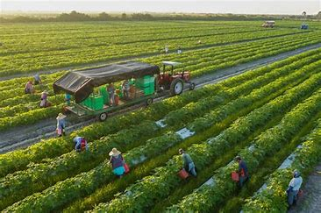

**What is Organic Farming Meaning?**

In simple terms, the meaning of organic farming is that it is a farming process where use of fertilisers and pest control means are created or acquired from organic materials. Such a process does not enforce a harmful and degrading effect on our environment.

All operators who are engaged in such a type of agricultural process comply with the strict particulars which favour non-polluting farming and thereby respect the ecosystem and its residents.

**What is the Relevance of Organic Farming?**

The current agricultural system in most countries primarily focuses on the production output. The Indian agricultural sector remained self-reliant during the emergence of the green and golden revolution. It also launched multiple farming techniques, such as HYV seeds, fertilisers and pesticides, which adopted advanced technology to focus heavily on the generated output

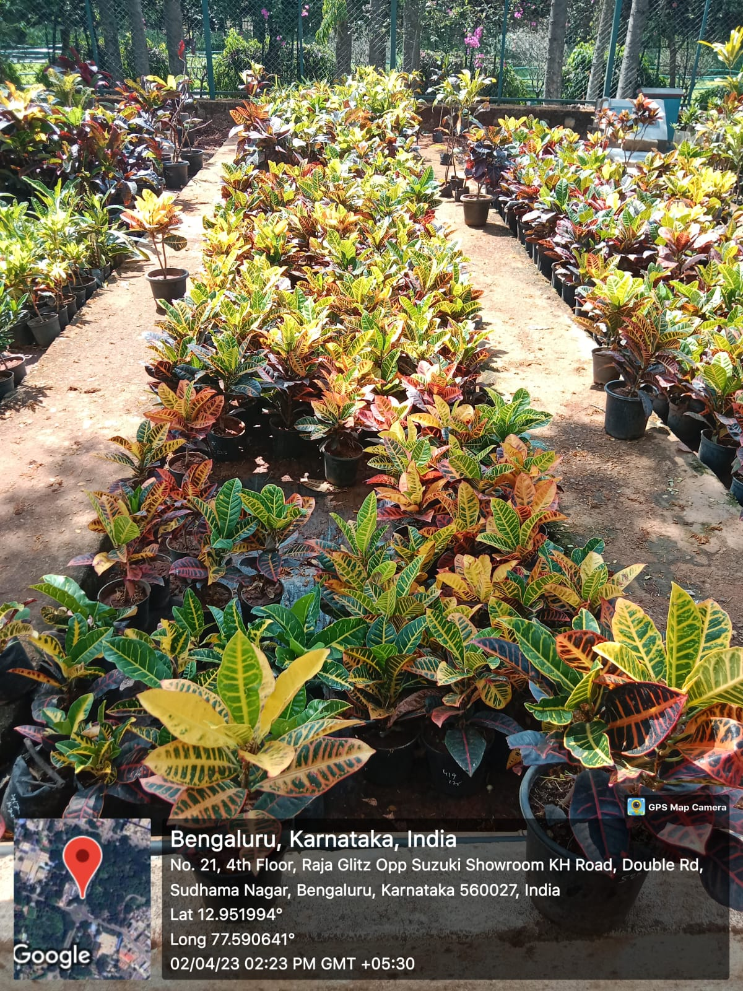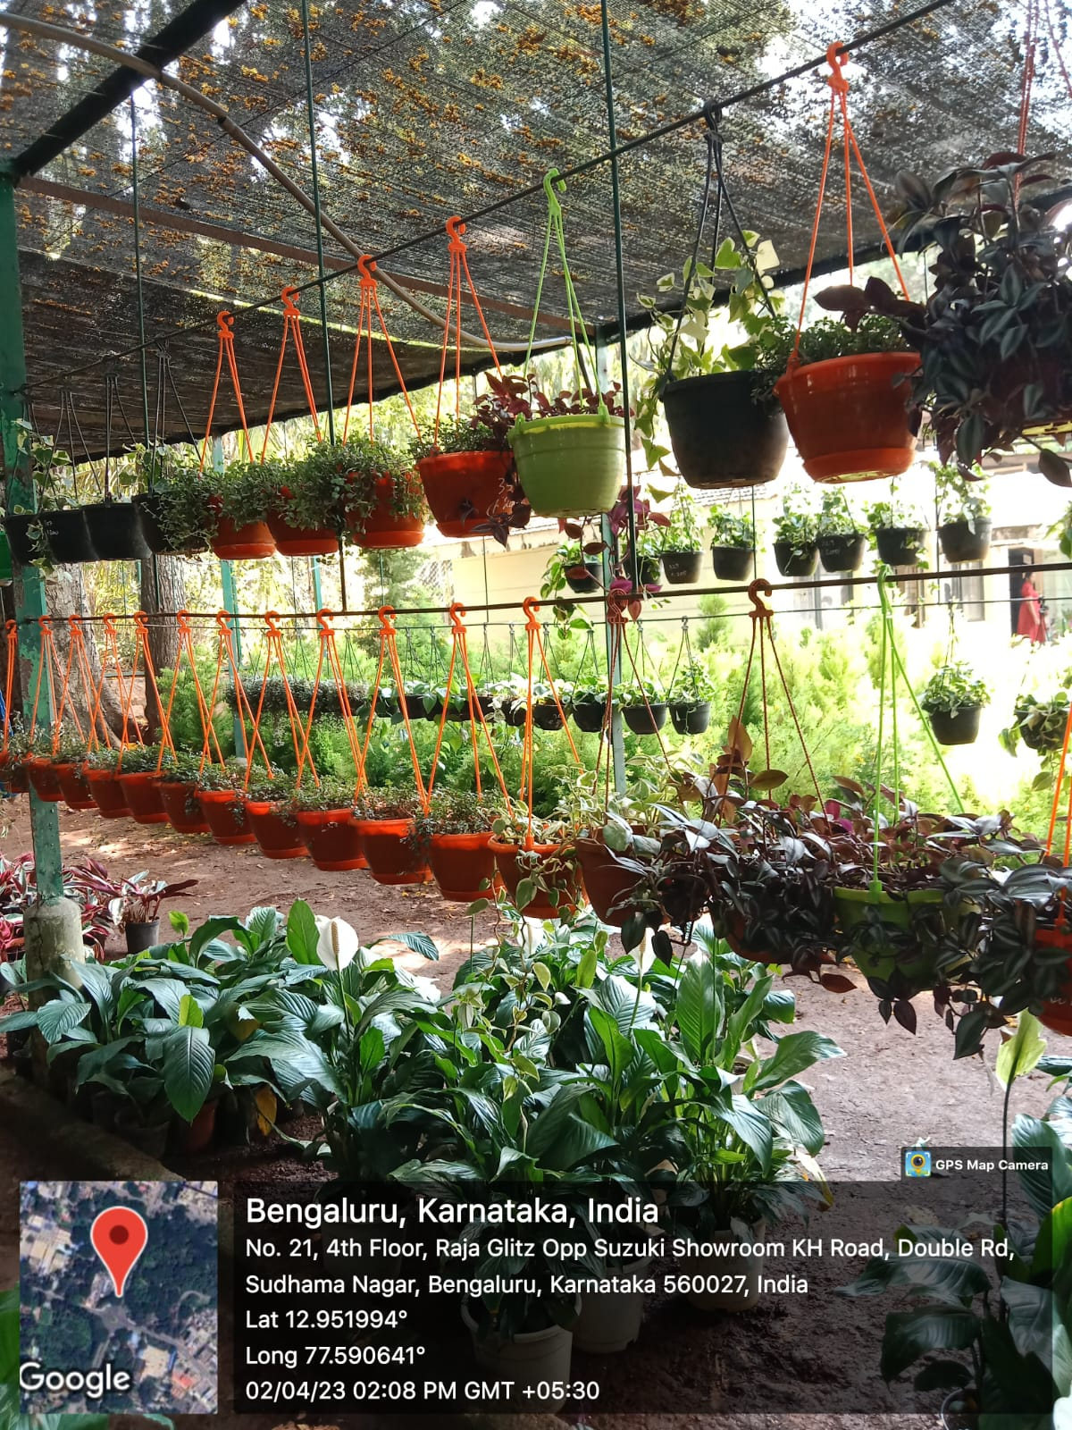

* **Green Revolution**

During the time of famines, the green revolution helped a lot in leading to a drastic rise in the stock of food grains in India. Our country not only

managed to remain self-sufficient but also became one of the top producers of food grains across the continent and beyond.

Our country introduced HYV seeds, pesticides and fertilisers created with the help of adept scientific research, in an effort to increase productivity by a significant amount. This was one of the driving factors of the green revolution, which subsequently helped India to become one of the leading producers of rice and wheat across the globe.

**Environmental Impact**

However, such farming processes eventually led to severe deterioration of our environment. Organic farming was introduced as a solution to environmental impact which is increasing each passing day for the over-use of harmful chemical, pest control tools and synthetic and inorganic fertilisers.

In other terms, this form of agricultural process is an innovative system of farming which helps substantially to repair, maintain and enhance ecological balance.

Hence, it can be concluded that the scope of organic farming in India to bring in more profits is quite high as lesser pollutants in our environment will help to yield top-quality crops which will, in turn, generate higher revenue.

Moreover, since organic farming requires fertilisers and pesticides to be made of biodegradable elements, the cost of production will also be comparatively lower.

**What is the primary objective of organic farming?**

1. Promote eco-friendly farming
2. Produce more crops
3. Both
4. None of the above

**What kind of seeds were used for high yield during the green revolution?**

1. HVY seeds
2. HYV seeds
3. VYH seeds
4. VHY seeds

**What do you Understand from the Concept of Organic Farming?**

As per the definition of organic farming, it is clear that the objective of organic farming is for the betterment of the ecosystem. Moreover, organic farming is also the answer to the search for sustainable development in the Indian agricultural sector without resulting in depletion of natural resources, which will surely help us to restore the country’s ecological balance.

According to a recent analysis on 50 and above types of crops grown in about 15 countries across five continents, substantial data was received to judge the longevity of the financial stability surrounding organic farming.

Data suggested that there are multiple factors which affect the financial elements behind organic farming. These include –

Production yield

Labour expenses

Price of premiums for biodegradable products

Affordability of going through a phase of reduced earnings during the transition from traditional farming to organic farming

Cost-saving potential from lesser use of non-renewable resources and their accessory tools and machinery Based on all these factors, analysts conducted a cost-benefit study which proved that organic farming is comparatively more profitable than traditional agricultural processes.

Data also showcased the fact that the labour cost for proper usage for mechanical pest control and other approaches such as weeding, marketing and selling of biodegradable products was comparatively higher than conventional agricultural systems.

**Cost - Benefit Analysis of Organic Farming**

The cost-benefit analysis indicates that the economic advantages of organic farming help to offset these costs and thereby incur a higher overall profit. The price premiums and lesser requirements of expensive fertilisers and pesticides make up for the increased labour costs of implementing such a kind of farming process.

Moreover, this analysis also helped to determine that the labour-intensive features of organic farming techniques possess the potential to revitalise the economic condition of rural sectors of the country. Hence, organic farming benefits can help in redistributing agricultural resources in rural areas and therein promote financial stability through various openings in employment.

Another important data derived from the above cost-benefit analysis stated that several organic farmers depend primarily on the production of one or more crops in search of a steady source of income.

Hence, organic farming can also help our country’s agricultural sectors to encourage production of multiple types of crops simultaneously.

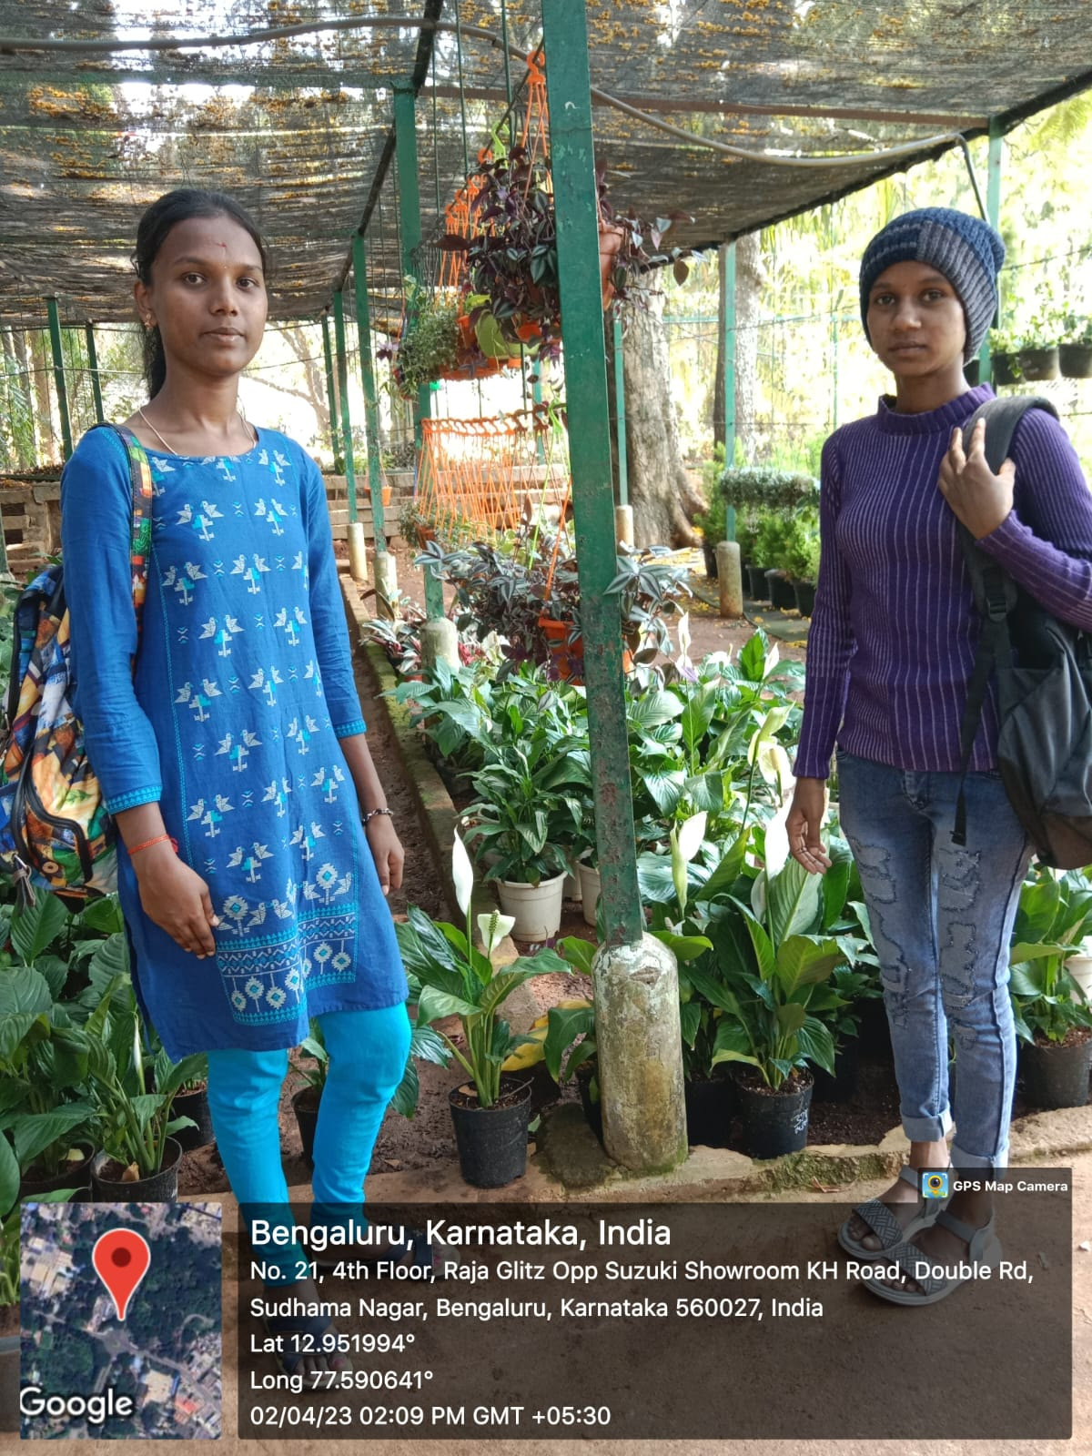



**Importance of Organic Farming**

The above discussion regarding the cost-benefit analysis of organic farming techniques and the traditional forms of agricultural processes implemented throughout the years help us to realise the importance and benefits of organic farming.

The importance of such a kind of agricultural technique is summarised in these points mentioned below –

1. **Organic Farming Helps to Maintain Ecological Balance**

The most important factor of organic farming is its strength to maintain ecological balance. The environment that humans survive in is affected each and every day with harmful ingredients. This affects the ecological system, which in turn brings hazardous effects on our daily lives that most are unable to recognise.

Organic farming uses biodegradable products which do not harm the Earth’s soil compared to conventional agricultural methods. So, this farming process is essential in maintaining the ecological balance.

1. **This Farming Technique is Cost-Effective**

According to a cost-benefit analysis portrayed above, organic farming techniques require increased costs on labour expenses. Since, mechanical pest control along with other methods that need constant labour is a primary feature of organic farming, initially overall expenses may seem to be comparatively higher than traditional agricultural methods.

However, the price premiums and lesser use of expensive agricultural fertilisers and pest control tools make organic farming processes more cost-effective than conventional agricultural techniques.

1. **Use of Biodegradable Items Improves Production Quality**

Organic farming acknowledges use of biodegradable items which act as stronger fertilisers than the synthetic fertilisers used in traditional farming methods.

Synthetic chemicals used in these fertilisers can help in producing an increased number of crops, but they come at a huge price, i.e. degradation in quality of the produced crops.

**3.2 WASTE MANAGEMENT:**

A waste management system is the strategy an organization uses to dispose, reduce, reuse, and prevent waste. Possible waste disposal methods are recycling, composting, incineration, landfills, bioremediation, waste to energy, and waste minimization.

Waste can be solid, liquid, or gases and each type have different methods of disposal and management. Waste management deals with all types of waste, including industrial, biological, household, municipal, organic, biomedical, radioactive wastes. In some cases, waste can pose a threat to human health.

Health issues are associated throughout the entire process of waste management. Health issues can also arise indirectly or directly: directly through the handling of solid waste, and indirectly through the consumption of water, soil and food. Waste is produced by human activity, for example, the extraction and processing of raw materials.

The generation of solid waste is a major environmental problem faced by most of the world. The management, proper disposal, and reuse, in the most appropriate and planned manner are the daily challenges faced by Indian cities.

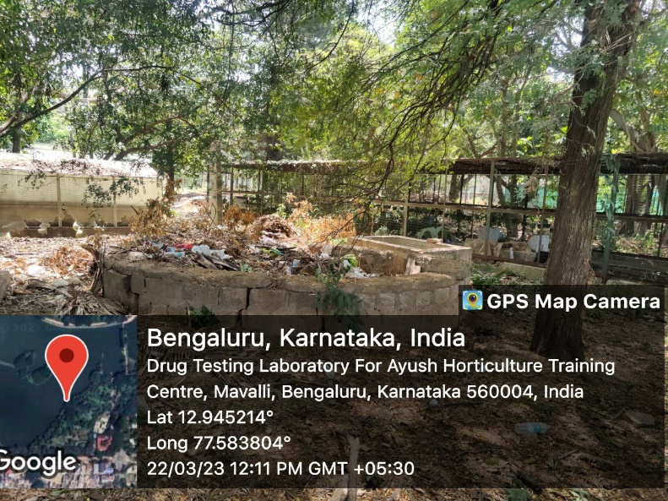 While typically households and bulk generators are seen as the primary source of municipal waste, major events, which produce a huge amount of waste in a short time have emerged as a challenge in urban spaces.

Located in the southern region of Garden city Bengaluru, Lalbagh is one of the largest botanical gardens of South Asia. Every year in Lalbagh Botanical Garden the Directorate of Horticulture, Karnataka organizes the Biennial Flower show in January and August on the occasion of Republic Day and Independence Day respectively.

The flower show held in the Glass house is known to have the largest collection of tropical plants in India. The Lalbagh Garden has hosted two hundred and ten flower shows in the past 105 years of the park. In a recent survey conducted by the authorities, the number of visitors attending the flower show gradually increased from 2 lakh to 4.5 – 5 lakhs in the past five years. The quantity of waste generated was tremendous – about 8 to 8.5 tons.

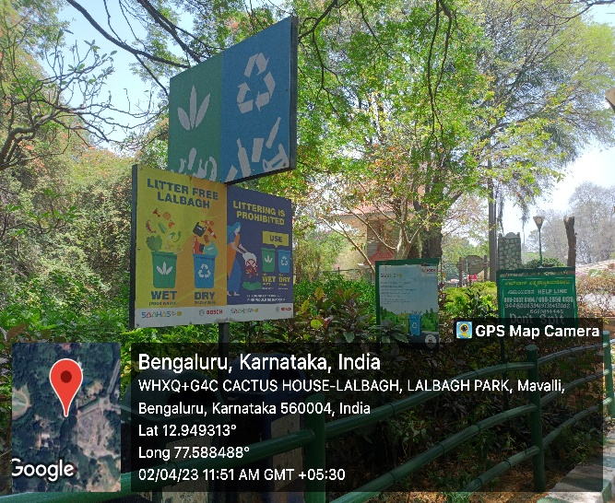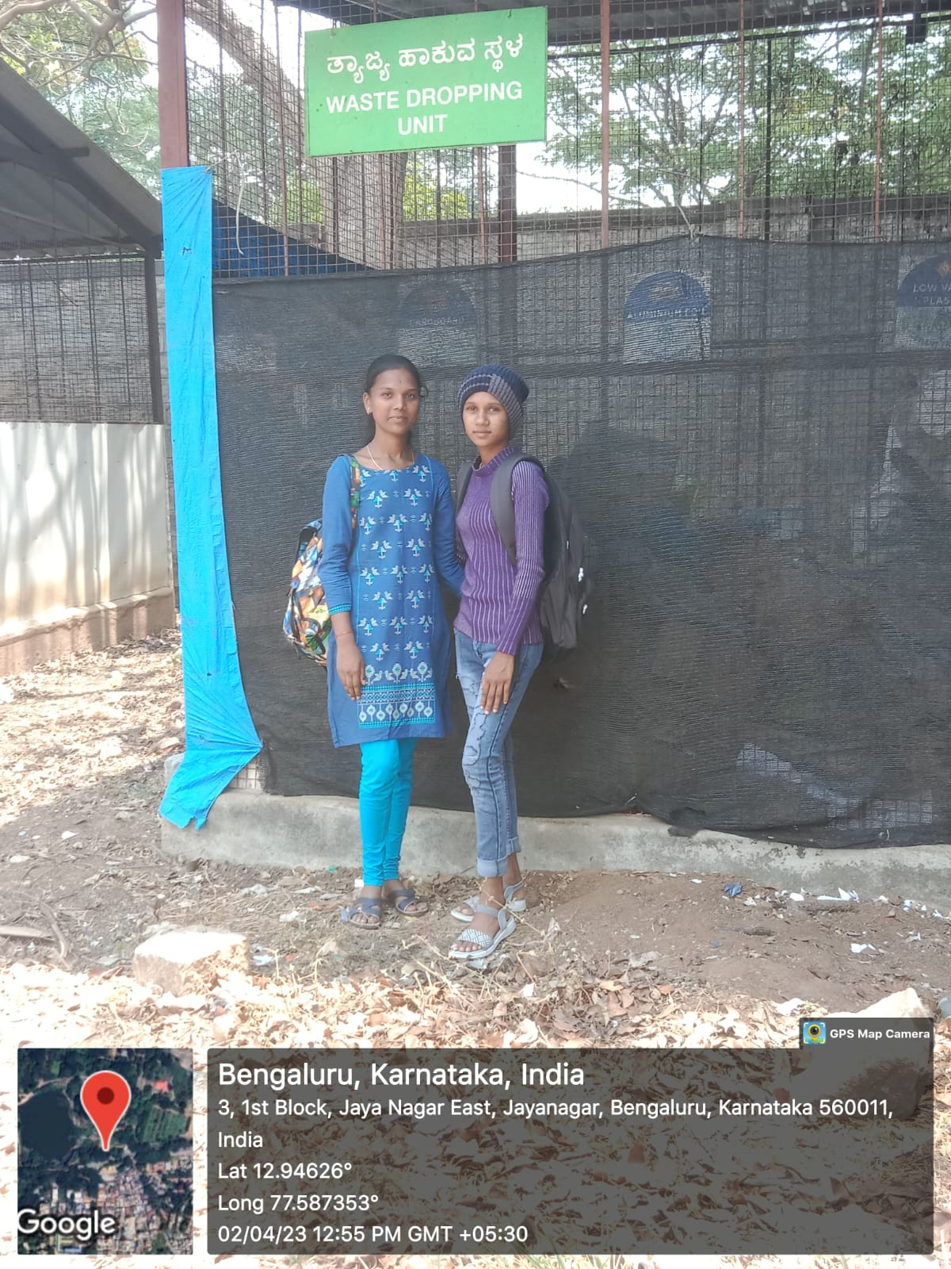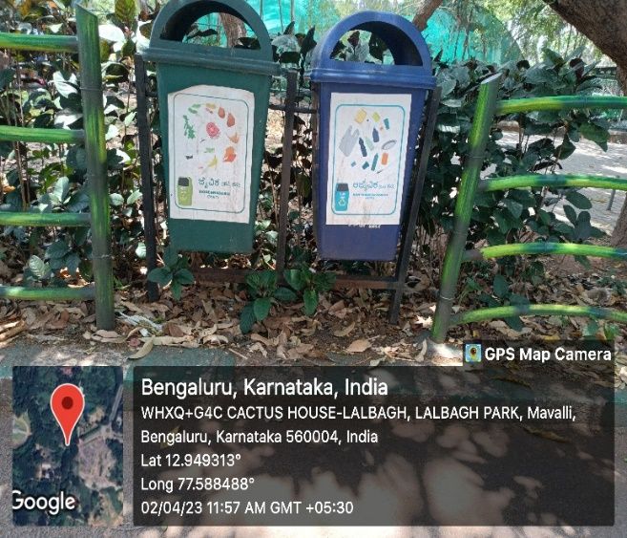

**CHAPTER 4:**

**WATER MANAGEMENT**

**What is Water Treatment?**

Water treatment refers to the process of improving the quality of water with the purpose of serving an end-use. The most common end-uses include drinking water, industrial water supply, water recreation, and for replenishing environmental sources, such as rivers and lakes.

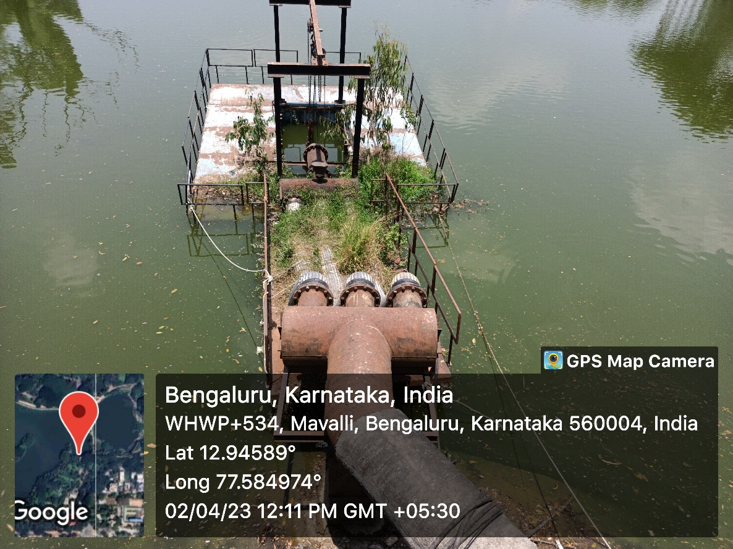

**Why is Water Treatment Important?**

Clean water is a basic necessity for humans. While the human population grows, the demand for water grows as well. Since water is a finite resource, used water must be treated to continuously serve end-uses. This is where the importance of water treatment systems comes in.Water treatment helps in removing contaminants and hazardous substances from the water, making it clean and safe to drink and be used for other purposes.

Unfortunately, [almost 2 billion people](https://www.who.int/teams/environment-climate-change-and-health/water-sanitation-and-health/water-safety-and-quality/household-water-treatment-and-safe-storage) in the world use either untreated drinking water or get water from unsafe or contaminated sources. Having systems in place to improve water quality helps intervene in these situations and prevent unsafe water-caused incidents, such as water-borne diseases and fatalities.

On the other hand, water treatment is also helpful in ensuring that water gets reintroduced back to nature’s cycle. One of the end-uses of this process is to safely return water to environmental sources like rivers, lakes, and oceans. Of course, water treatment facilities must ensure that water is free from harmful substances before doing so to avoid contamination and other environmentally disastrous issues such as [water pollution](https://safetyculture.com/topics/swppp/).

The United States Environmental Protection Agency (EPA) sets forth guidelines for organizations for protecting the environment and human health. One of the violations that an [EPA report](https://safetyculture.com/checklists/epa-report/) helps keep in check regarding an organization’s compliance with environmental safety is the illegal discharge of pollutants that could end up in bodies of water. An example of this is dumping untreated and contaminated wastewater directly into the sewer system, which is a violation of the Clean Water Act.

**Process**

In most cases, water treatment plants are responsible for collecting, treating, and distributing supplies of water, whether for residential, commercial, or industrial uses. Globally, these facilities may follow slightly different processes in their water treatment systems. However, their methods are all based on similar stages depending on the end use they aim to achieve.

Water scarcity is serious problem throughout the world for both urban and rural community. Rainwater harvesting is defined as process of augmenting the natural infiltration of rainwater or surface water into the ground by some artificial methods.

To collect and store the rainwater which fall on the rooftop of buildings. The rainwater can be stored in tanks or diverted into dug well or borewells, recharge pit and recharge well trenches.

The pristine lake at the Southern end of Lalbagh Botanical Gardens in Bengaluru is a nature lover’s delight. Popularly called the Lalbagh lake, the water body which is spread over 40 acres is home to various aquatic species and attracts a large variety of birds. The lake also meets the water requirements of the garden which boasts of nearly 2,000 species of plants and trees from across the world. But due increase in pollution, climatic change and negligence from the authorities, this lifeline for all the species in Lalbagh faced a threat of nearly being wiped out.

The Department of Horticulture has used an ingenious method of rainwater harvesting to water the thousands of plants in the park. The strategy implemented to overcome the water scarcity is rainwater harvesting pits and surface water flow to newly created pond.

There are 209 rainwater harvesting pits in Lalbagh. The Department of Horticulture had dug up 85 rainwater harvesting pits. United way and Bosch have sponsored 124 rainwater harvesting pits. Each pit is 18 ft deep and 3 ft wide. According to the local authorities, 124 pits are capable to harvest 1,33,92,000 litters and remaining 85 pits are capable to harvest 1,08,83,400 litters of rainwater for a period of 30 days of rainfall. The excess water is sent to the pond thereby utilizing most of the rainwater.

These underground pits also help in raising the water table in and around the botanical garden which would greatly boost the ground water reserves. Warli art has been painted on the lids to promulgate among the public visitors of Lalbagh.

### What are the 5 steps of water treatment?

According to the [Centres for Disease Control and Prevention (CDC)](https://www.cdc.gov/healthywater/drinking/public/water_treatment.html), the overall water treatment process, especially for public water systems, consists of 5 major steps:

Water Treatment Process | Source: Centres for Disease Control and Prevention (CDC)

#### **1. Coagulation**

The first step of getting water treated is through coagulation. This involves adding chemicals with a positive charge to the water which should neutralize the negative charge of dirt and other dissolved substances. Such chemicals include iron and specific types of salt.

#### **2. Flocculation**

This step refers to the process of gently mixing the water to create larger, heavier particles known as flocs. In most cases, additional chemicals are being added to the water to allow the flocs to form easily.

#### **3. Sedimentation**

Once flocs form, they settle to the bottom of the water because they are heavier. This is called sedimentation in water treatment, which is one of the processes that water treatment plants use in separating the solids, such as flocs, from the water before going to the next step.

#### **4. Filtration**

The water again goes through another process of solids separation through filtration. The separated, clear water on top now passes through filters with various pore sizes, made from different materials such as sand and gravel. Ultimately, these filters are in place to help remove dissolved particles and unwanted substances from the water.

#### **5. Disinfection**

During this step, any remaining parasites, bacteria, and viruses must be eliminated. This can be done by adding one or more chemical disinfectants to water such as chlorine or chlorine dioxide. Why do water treatment plants do this? It’s to keep water safe when traveling from the water treatment plant to homes and businesses because chemical disinfectants help eliminate the remaining unwanted microorganisms before the water reaches the intended end-use.

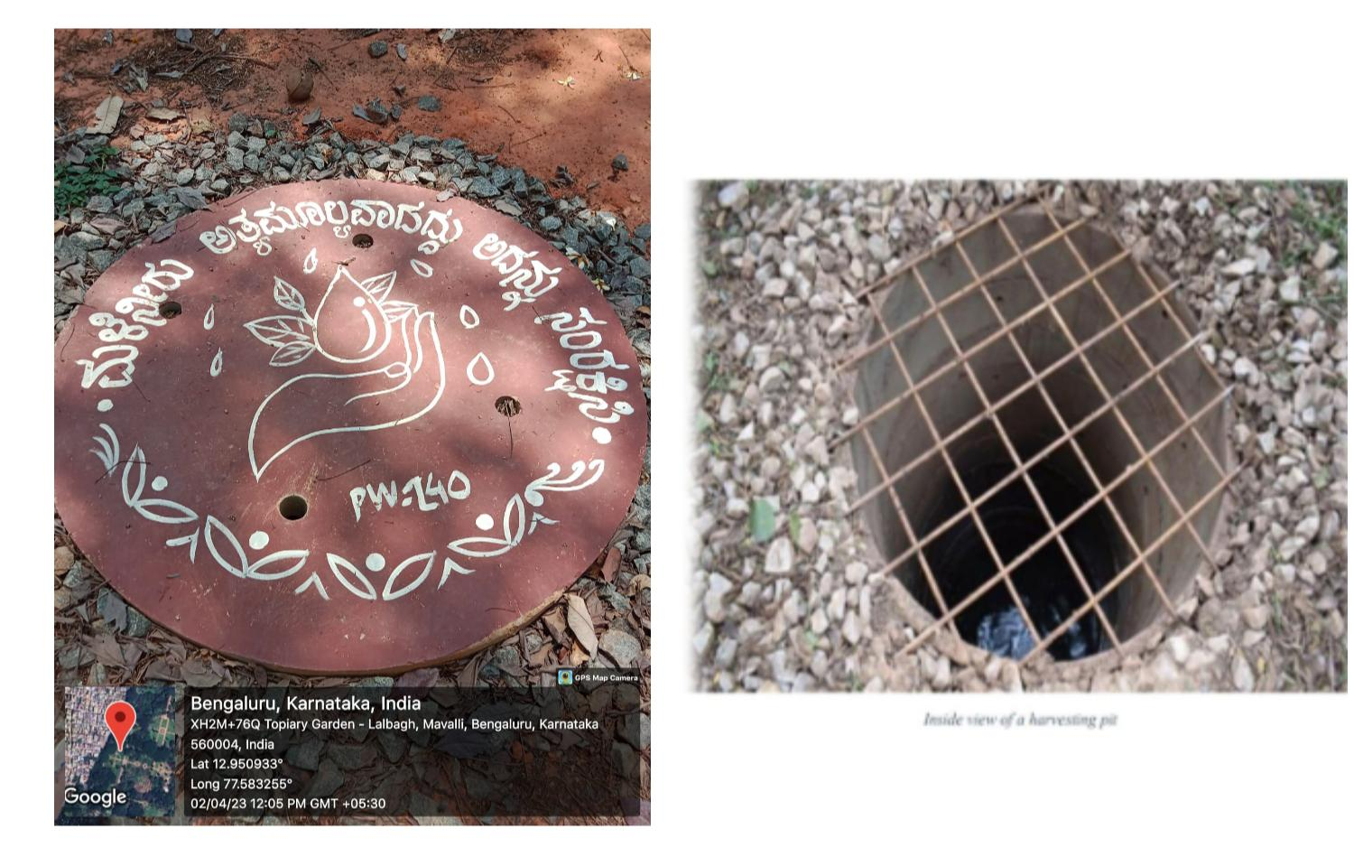

**CHAPTER 5:**

**FOOD WALK**

Food walks form an integral part of culinary tourism across the world. It is a fun concept to take part in if one is a food lover and are interested in understanding people and their lives through the lens of food, while munching the way through different delicacies.

To be honest, there is hardly any better way to explore a new city than a food walk. It helps to taste and savour different local food, visit many offbeat places, and experience the city like a true local. During a food walk, one usually goes out with a group of people or friends, led by an expert who in turn is also a foodie.

In this walk, let us explore one of the most iconic, historical, and famous throughout all generations in Bengaluru.

 Vidyarthi Bhavan**, a heritage South Indian vegetarian restaurant, started in 1943 as a small student's eatery (from where it gets its name), has become a place that makes up part of the culinary history of Bangalore and which has metamorphosed into what it is today, a place where time and tradition have stood still, drawing people from all walks of life. It is on the quintessential foodie’s guide to Bangalore.

A legendary south Indian vegetarian breakfast joint, it is in the heart of Bangalore in Basavangudi. Bearing very simple interiors, usually crowed, surprisingly quick and efficient service, this place has the potential to make one reminiscent of Bangalore in 50s.

My friends and I reached Vidyarthi Bhavan, huddled in a line, squeezed through the way into the benches allotted. We kept our orders simple – Masala Dosa, Kara bath/Upma, Vade and Filter coffee. Food arrived within few minutes after ordering. In fact, one of the specialties here is the way they carry over many plates of dosa and the style of serving.

The dosa here is very unique-crispy, golden brown and indeed tasty. The upma is also tasty and the vade in particular is very crisp though being covered by chutney. We enjoyed our meal, savouring every bite and summarizing our meal with mind freshening filter coffee.

Since 1943, this place continues to be one of the most popular food joints of Bengaluru and a must visit for all to experience the food and the heritage of the city.



**Roti Recipe | Chapati Recipe: -**

The flatbread known as roti has many variations all over different regions of India. Whereas I call this particular type of roti, phulka, hubby just refers to them as roti. Toe-may-toe, toe-mah-toe, phulka or roti. Either way is correct!

That said, much like the word “bread” can mean everything from a slice of sandwich bread to a French baguette, roti is also a broad category of flatbreads. While all pulkas are rotis, not all rotis are pulkas.

As far as the dough is concerned the same dough is used to make roti, phulka and chapati. This basic simply consists of whole wheat flour, salt and water. Fats like oil or ghee are optionally included. I prefer to add some oil or ghee in the dough as it makes these flatbreads soft.

Other types of roti varieties include [**Messi Roti**](https://www.vegrecipesofindia.com/missi-roti-recipe/), **[Rumali Roti](https://www.vegrecipesofindia.com/rumali-roti-recipe/)**, **[Ragi Roti](https://www.vegrecipesofindia.com/ragi-roti-recipe/)**, and [**Tandoori Roti**](https://www.vegrecipesofindia.com/tandoori-roti-recipe/), among others. All these roti variants taste different as they are made with different grain flours (like millet); or have various unique seasonings; mashed or chopped greens like spinach; or herbs added to the dough.

## What is Chapati

A chapati is a very rustic version of the traditional roti recipe. The word “chapati” is derived from a Hindi and Marathi word “chapati” which means “flat” or “slap”. Instead of rolling out the dough, traditionally chapatis were flattened by hand by slapping portions of the wheat dough.

Of course, it is time consuming to flatten the chapati this way, so nowadays a rolling pin is often used. A chapati can be also thin or medium rolled, much like phulka. While a phulka is smaller in size, a chapati is larger in size.

Chapati are only roasted on the skillet or tawa. While roasting they may puff or not. Roasting them with oil or ghee is also optional. Again after being roasted, it is optional to brush them with fats like ghee or oil.

## What Kind of Wheat Flour for Roti

These flatbreads are always made from whole wheat flour and water, though ghee and salt may or may not be added. I prefer adding some salt and ghee to the dough for a bit of extra flavour and a more tender result.

The whole wheat flour used for making these flatbreads is known as “atta” in India. Even today, many Indians make their own atta by visiting local grinding mills (called chakki in Hindi). The wheat grains are stone ground making for a really fine flour.

If you do use the wheat flour milled in the United States or Europe or any other country, then sift the flour once or twice to get rid of the bran. Atta is finely milled and ground than the wheat flour that is available outside India.

The best, softly textured roti comes from the Sharbati wheat that is cultivated and grown in the Madhya Pradesh state. I use this Sharbati atta to make roti, and if it is possible for you to get your hands on some, I highly recommend it.

Living outside India? Buy atta from an Indian grocery store or from Amazon or other Indian online stores. Preferably use sharbati atta to get soft and tender roti and also try to get organic atta.

As the roti or chapati recipe is made from whole wheat flour, they are both healthy and easy to digest. In this post, I will explain the basic method of making roti or phulka in 3 ways so you can have this yummy Indian staple at home. Let’s get started

## Knead and Roll Roti Dough

1. Take 3 cups of whole wheat flour (atta) in a bowl. Add about 1 teaspoon of salt or according to taste. Add a bit of water and 1 to 2 tablespoons ghee or oil and start mixing.

For the oil you can use sunflower oil, avocado oil, grapeseed oil, rice bran oil and also peanut oil.

You can measure and keep about 1 to 1.25 cups of water that you will be needing depending upon the quality of the flour.

3 cups of flour might be difficult to handle and work upon. So you can reduce the quantity of flour if needed.

2. Adding water to the dough in parts, begin to knead the dough.



3. Continue to knead the dough. Keep adding water as required, knocking the dough down as you knead to create more gluten.

At the final stage of kneading the dough, some people prefer to throw the dough from a height of approximately 1 to 2 feet to the bowl while kneading. This helps in making the dough soft. I personally prefer to apply pressure from my fist rather than using the throwing method. In the pic below you can see the hand posture which is used to knead the dough.

4. Keep on kneading till the dough becomes pliable and soft. The final dough consistency should be neither sticky nor hard. The dough for rotis is more softer than the dough kneaded for [**Poori**](https://www.vegrecipesofindia.com/poori-a-kind-of-fried-indian-bread/) (Indian Fried Bread).

After kneading the dough, cover it with a plate or cloth and allow it to rest for 20 to 30 minutes. While you can make the roti straight away after kneading the dough, this 30-minute waiting period helps the gluten relax, which makes it easier to roll out.

Note: You can also use a stand mixer or roti maker appliances to knead the dough if you prefer.



5. Now make small to medium balls of the dough. Roll the balls in the palms of your hands to smoothen it. Flatten the ball and place them on a rolling board or a clean kitchen countertop.

Sprinkle some whole wheat flour on the dough ball. Alternatively, you can also dust the rolling board with flour.

7. Turn on the gas stove and put the tawa to make it hot. The tawa has to be sufficiently hot to make soft roti. I generally make rotis on a medium-high flame.

NOTE: On “sim” or low flame, the roti become hard; and on a very high flame they cook too fast. So regulate the temperature while making the roti.

So how do you find out if the tawa is hot enough to make roti? We sprinkle little whole wheat flour in tawa or griddle. If it darkens quickly then the tawa is ready to make roti.

8. While tawa is getting hot, start rolling the dough ball into a flat round circle.



9. Keep on rolling till you get an even circle as shown in the picture below. Making the roti round is not easy!

With practice, you will be able to roll them round, but if they are a little misshapen at first, they will still taste good. Sprinkle some wheat flour if the dough begins to stretch or become sticky while rolling.

The trick to rolling round roti is that when you are rolling the dough then the roti should also be moving in a circular direction.

Also make sure that the rotis are not too thick, as they will take too much time to cook and will not puff up as they should

Note: While rolling the dough, do not coat it with too much of the dry wheat flour. The flour should be lightly used and just enough to help you with the rolling. Too much flour on the rolled roti dough will make for a denser texture. The dry flour particles also burn while roasting and stick to the outer surface of the roti.

**CONCLUSION:**

Social responsibility is a component of economic and social sustainability that influences the quality of life of communities. Therefore, people must be the starting point, as they participate in solving the problems of society. In this process, the universities have a fundamental role because in them there is a relationship between academia and reality and they are agents of social change. In this way, university social responsibility emerges as a policy of performance, they have of HIES. Of students, professors and managers by influencing the loyalty, satisfaction and perception

Students perceive social and institutional connectedness as overlapping constructs, a significant consideration that can shape future studies on student connectedness and satisfaction. Connectedness is developed through relationships with friends, other students, instructors, and campus personnel. The present study provides a nuanced understanding of how connectedness emerges, how demographic variables affect its development, and how various elements of connectedness relate.